# **PSP Flow**

Log into XPOS

Add SKU: 10101070

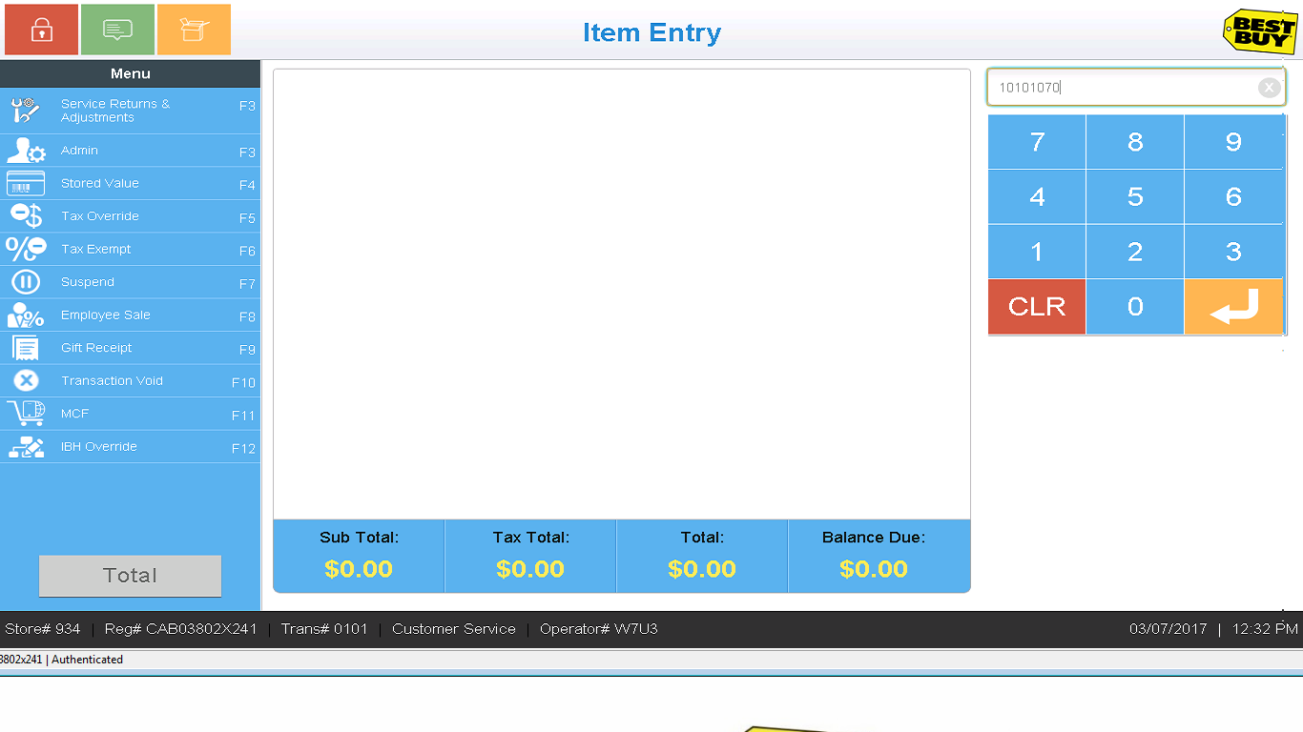

SKU added to transaction. Click on the PSP in the right hand side menu.

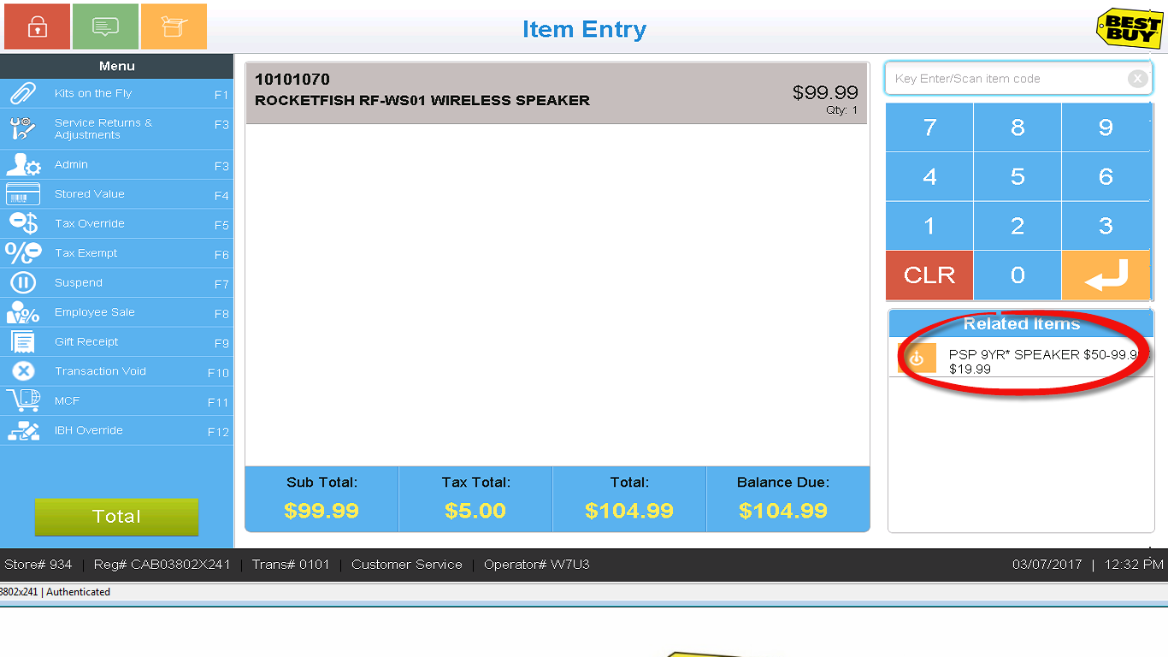

Search for an existing customer.

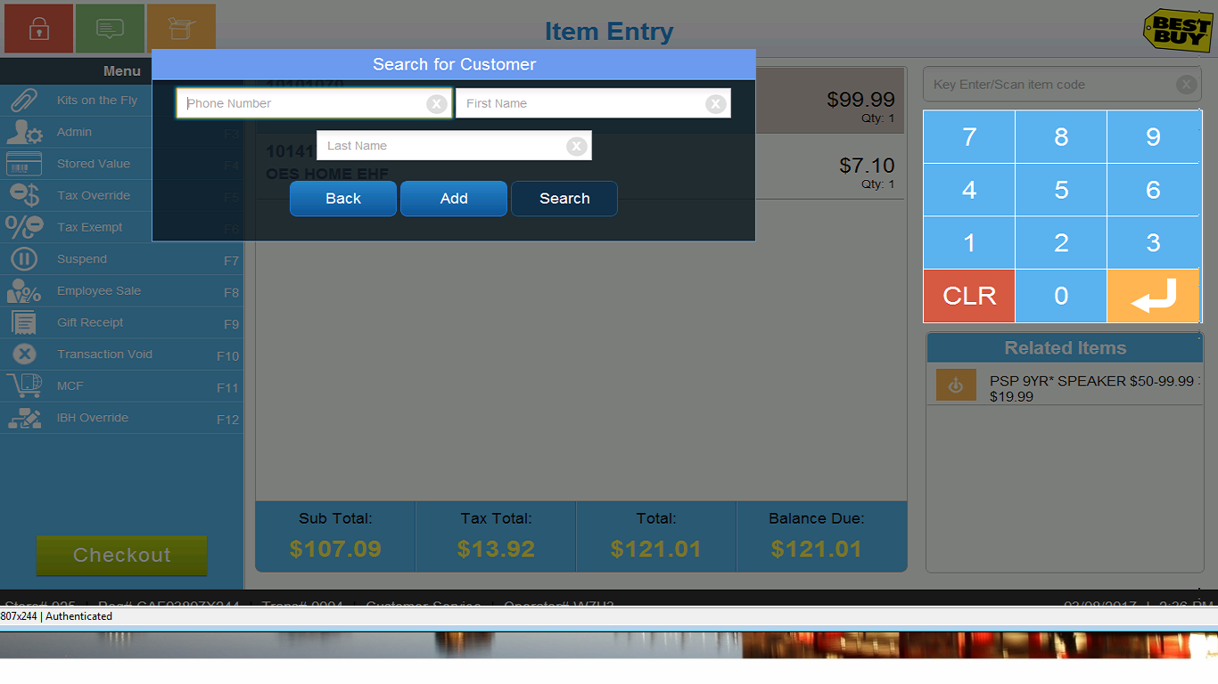

Search results

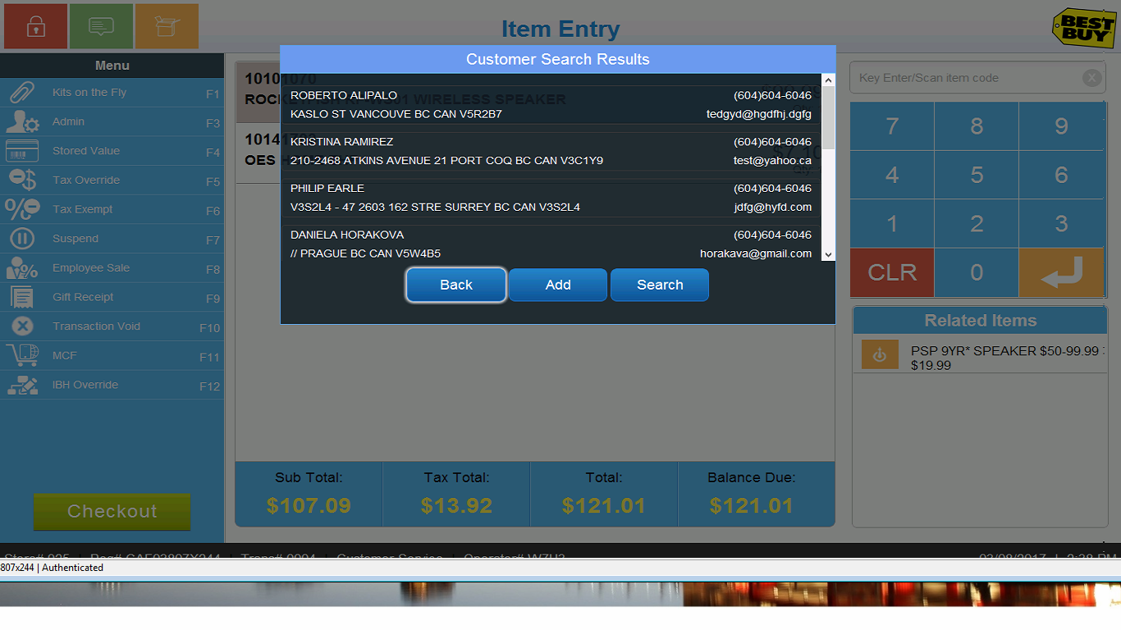

OR create a new customer

